**Analysis-Screenshots for “Multiple_year_stock_data” - (Solved)**

**Tab 2016**

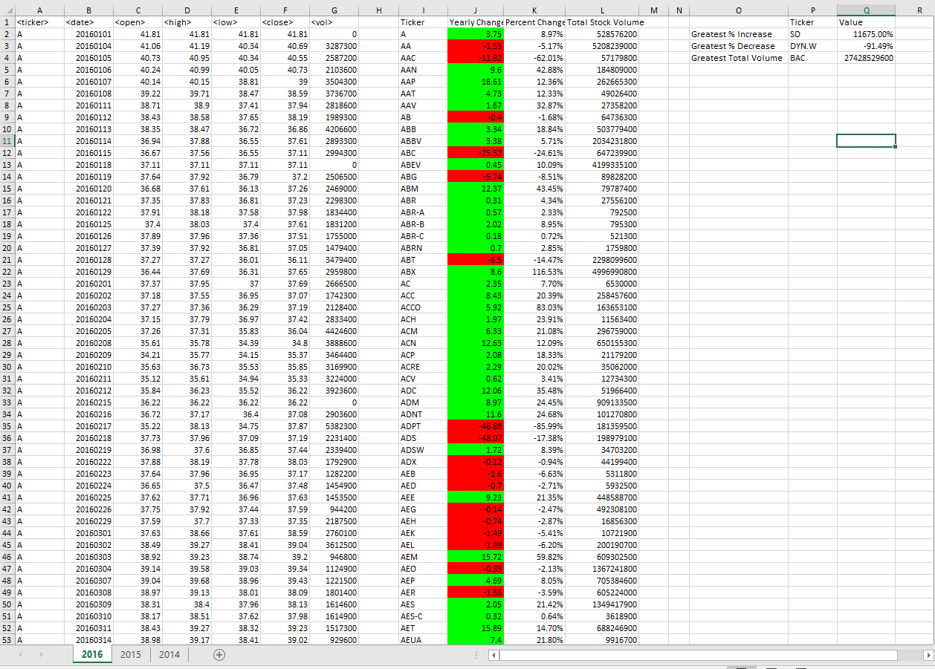

**Tab 2015**

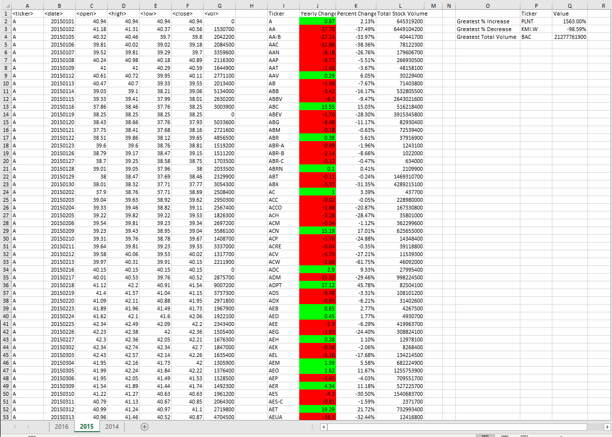

**Tab 2014**

